

**AGE CONCERN, TEIGNMOUTH AND SHALDON**

**ANNUAL REPORT**

**YEAR ENDED 30TH JUNE 2019**



Company Registration Number 2338079

Charity Registration Number 800996

**Chairman’s Report**

There is no doubt that Alice Cross was visionary and ahead of her time when she established the Alice Cross organisation. As such, it was an honour to become Chair of the board of Trustees in July 2019.

As a board of volunteer trustees, we are unanimous that the core values which we believe were intrinsic in setting up the Alice Cross are as important today as they were when the centre was created. As chair, I will at all times endeavour to ensure that these values remain at the heart of everything we do as a board.

We have to say farewell to two of our trustees who decided to stand down from the board earlier this year. Maggie Harris and Sandra King. I would like to publicly acknowledge their amazing contribution and service to the Alice Cross Centre. Their hard work and commitment with volunteers, staff and clients has been inspirational and will be very much missed by everyone involved in the Alice Cross.

We face some challenges over the next few years including acknowledging that

* There’s no such thing as a “typical older person”
* that funding opportunities are changing (e.g. the end Age UK funding)
* that as our population is forecast to live longer, be more active and healthier in older life compared to when the Alice Cross centre was established.
* there needs to be an emphasis on developing preventative and wellbeing services to support people in the future.

One of our core values is “Willing to change and daring to be different” and as we move to the future, we must be willing to change and adapt to ensure the longer future of the Alice Cross.

As chair, as a board of trustees and as staff, we can only do this with the continued support of our volunteers and clients.

I very much look forward to an exciting future working with ALL people involved in the Alice Cross.

Finally, I would very much like to thank Julia Street for her outstanding management and contribution to the Alice Cross Centre.

**Paul**

Paul Burgess, Chair of Trustees

6th November 2019

## Centre Manager’s Report

It has been another very eventful year for The Alice Cross, moving on from last year’s historic celebrations of 40 years at this site and over 70 years in existence for the charity. We were delighted to be recognised for our work in the community as runners up in Teignbridge Council’s Community Champion award in December.

We have been working on adding more services and activities in line with the Government pledge of an extra 20.5 billion to reform the NHS and introduce the Ageing Grand Challenge – to seek 5 years’ longer healthy life expectancy by 2035.

Our own Research showed three key elements;

* Encouraging physical health – Be and get active, eat more healthily
* Promoting personal development – Learn, develop strategies for resilience and managing change
* Fostering social improvement – Join in, take part and be part of a volunteer team or the centre “family”

Many of our activities are designed to promote physical wellbeing, improve skills and knowledge and there are plenty of opportunities for social interaction to help alleviate social isolation.

With the above ideals in mind, in January the board and management reviewed and agreed new mission, vision statement and core values

**MISSION STATEMENT**

**“Supporting the community by making later life a fulfilling and enjoyable experience”**

**Vision statement -**relevant for next 10 years and describe the current & future aspiration of the organisation

* **Community Centre of choice for improved health & wellbeing for all**

**Core Values**

* We act with compassion and integrity
* Every individual valued equally
* Working together to support the whole community
* Continually improving
* Willing to change and daring to be different
* It is vital to keep the centre feeling modern and meeting the needs and trends of people as they move from their final years in work through to retirement.
* It is vital to keep the centre feeling modern and meeting the needs and trends of people as they move from their final years in work through to retirement.

It is vital to keep the centre feeling modern and meeting the needs and trends of people. The centre is lively, vibrant and moving with the times. As older local people wish to try new things, learn new skills and enjoy their retired years, we aspire to work with them, other local organisations, the statutory sector, NHS & Councils to provide the services and activities our community needs to thrive.

## The Team

Age Concern Teignmouth & Shaldon currently has 9 Trustees. Paul Burgess has taken on the role of Chair of trustees. The Operations Manager is assisted by a part time administration assistant Alison Fenton and a part time cleaner Susan Hingley. Sam Triggs resigned in June and we would like to thank her for her work and volunteering for the organisation and wish her luck in her new role.

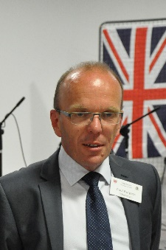 ** 

Paul Burgess –Chair of trustees Julia Street – Operations Manager Alison Fenton – Administrator

In July a new member of staff was taken on, Yvonne Lamond, as Volunteer & Activity Co Ordinator. We have seen an increase in the number of new volunteers and 2 new people coming on board as trustees as a result of her recruitment.

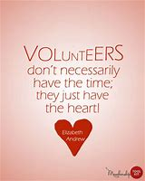

A vital element in the running of the Centre is our loyal band of over 50 volunteers giving an estimated **7500** hours a year – which would cost **£67,500**, if they were each paid £9 an hour. Without their help the Centre would find it almost impossible to function - so a huge thank you to all you wonderful volunteers. We encourage younger people of all abilities to enhance their skills and experience as volunteers and provide work experience placements for local students and opportunities for Duke of Edinburgh participants to fulfil part of their challenges.

## Activities

The centre continues to offer its traditional range of activities to ensure the general, social and physical wellbeing of our users. Exercise and dance classes improve strength and balance helping to prevent trips and falls, which are so prevalent in this age group and can lead to premature immobility. Our physical exercise classes are designed to help people of all ages, sizes and shapes, abilities and mobility.

Line Dancing continues to have a good following with the lead of Viv Wilson MBE and chair-based exercise is a firm favourite with Clive. To cater for those who have commitments during the working week, we now offer evening, afternoon and Saturday Pilates, Yoga and Eastern dancing classes.

Both seated and floor-based Yoga have been shown to improve blood pressure, alleviate the symptoms of arthritis and improve sleep, among many other benefits, including physical fitness and flexibility. The exercises, combined with relaxation and breathing techniques, improve overall health and wellbeing. Floor based Yoga was introduced during the year to cater for our more energetic users.

Pilates class helps to reduce the risk of injury which weight-bearing exercises can cause. Arthritis sufferers benefit because the gentle mid-range movements decrease the chance of joints compressing while maintaining the range of motion around them. For osteoporosis the simple and standing Pilates leg exercises may increase bone density in both the spine and the hip. The mid-range motion of the exercises can help people overcome rigidity and become more flexible.

Art and craft classes encourage new hobbies or the rekindling of old interests and provide the time and space to pursue these. The centre also provides accommodation for a variety of local voluntary community groups, including Bridge, Chess and Choral society.

Two new drama classes have started for children and young adults during the afternoons.

We have benefitted from Active Devon funding under the connecting actively to nature CAN scheme. Aimed at 55+ year olds, we ran a 12-week programme to take people from walking to jogging, to doing a 5km Parkrun on Teignmouth seafront. 6 of the 20 sign ups completed the Parkrun and now do it regularly.

In addition, CAN funded a project with Southwest coast path and Alice cross, “couch to coast” encouraging people to start walking with an aim to doing small sections of the coastal path. The members of the group enjoyed it so much that they are continuing with their own walks.

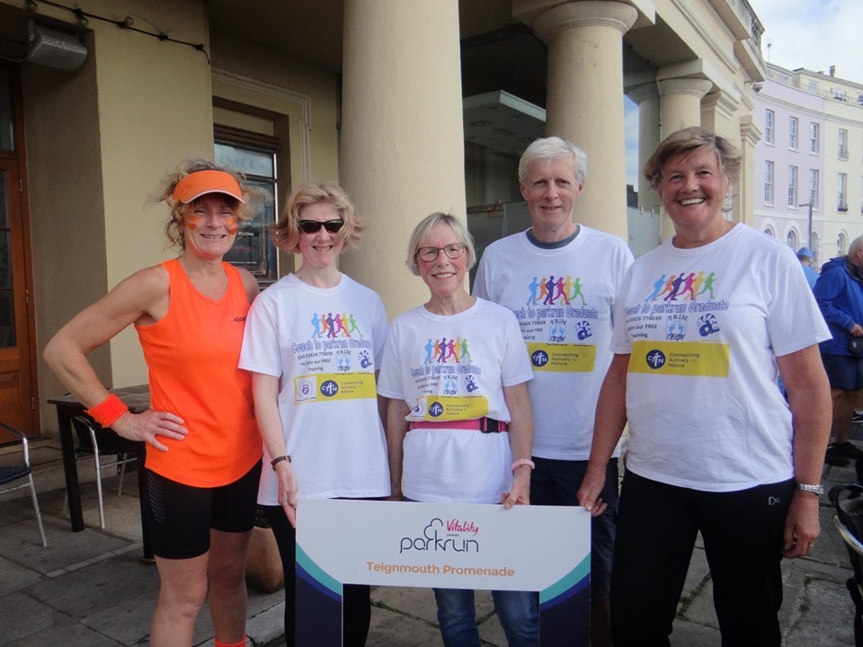

*Parkrun Sept 2019 left to right Julia manager, Helen, Nicky, Ed & Pauline.*

Fran Cragg & Gloria Noyes in the Monday club have organised lovely coach outings to Cardiff, Bath, Ottery, Widecombe on the moor and local garden centres, which were thoroughly enjoyed by those who went.

We have been able to continue our computer classes using iPads purchased this year and hold regular drop-in days. With so many services actively encouraging online booking and communication, including prescription renewal etc., these classes ensure that our clients can manage new procedures with confidence and at the same time enable them to keep in touch with local, national and global issues as well as their often, scattered families. Demand for these classes is high and we are constantly seeking funding to continue to offer them.



**Trim Teign weight loss programme**

launched at the centre, an additional weigh-in point to Teignmouth Hospital, supplemented in the Autumn with a new Trim Teign fitness programme which will increase the potential for weight loss by those who take part.

Pay £1 pw to Lose 1 lb pw and every £ goes to charity – aim to lose a stone in 3 months



September 18 – successful with obtaining grant from Sport England enabling further activities on Active Alice Mondays (+ Healthy Eating workshop, Zumba Gold & seated and floor-based yoga)

Over 100 participants registered to date, average weight loss over half a stone in 3-month programme, over £1000 raised for Alice and VIH

## Memory Café

Our weekly memory Cafés in the centre continue to play an important role in our work. This year we commenced an outreach programme, delivering Cognitive Stimulation Therapy and Digital memory therapy in a local care home. This is part of a planned expansion of the service to take in more local care homes and to provide an additional session in the centre each week.

Memory loss and dementia are becoming widespread and increasing problems and very often lead to isolation from the community for both sufferers and carers. A memory café held on a regular basis can curb this isolation and embarrassment by enabling sufferers, carers and friends to meet and chat unselfconsciously about their difficulties and be comforted by the fact that there are many people in a similar situation to their own. The atmosphere is relaxed and informal and participants can swap stories, ideas and tips on coping while taking part in a variety of activities to stimulate cognitive awareness. The aim is to provide support to the person with memory difficulty and an opportunity for the carer to have some stimulation and respite.

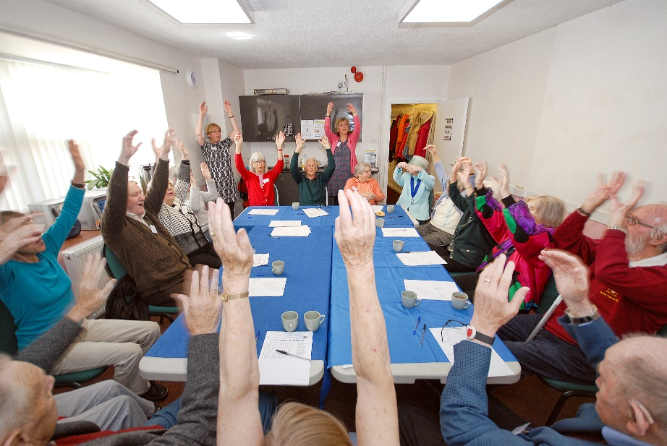

*Music for memories session*

At the end of January, we were successful in obtaining a pledge of up to £15,000 to help us with our memory work expansion plan, provided we could raise an equivalent sum in matching funds. Therefore, in March we started an intensive campaign to raise the necessary funds. By the end of June, we had raised £11,000 towards the total. We are drawing down the full pledge in November.

This will be an enormous boost to our memory support work and will ensure we can continue providing the service long into the future. It will also enable us to introduce extra activities such as afternoon themed teas, exercise, dance, yoga and start a “dementia choir”.

**Catering**

The daily weekday luncheon club continues, providing nourishing meals prepared in our 5* kitchen. Takeaway meals have increased, and we deliver to those who are housebound and live near the centre. One of our principal charitable aims is to subsidise hot meals as the benefit they provide to those who would otherwise be eating alone are an important element of the services we offer. The lunches are a social occasion, and it is a service that men, who are often more difficult to reach and engage with, are keen to attend daily.

After rationalising the catering function last financial year, and with the hours of time kitchen volunteers give the Centre, we are now breaking even. We do not aim to make a profit on this service.

Sunday Roast Lunch is normally provided once a month and sometimes twice depending on demand and availability of volunteers to run it. This is a favourite with local people and there are now groups who come together sharing taxis who regularly attend as a social outing.

Monthly Drive n Dine, partially funded this year by Tesco Bags of Help fund, continues with the help of Dawlish Community Transport who provide transport to and from the event where required. Some of our volunteers support this by providing additional transport. Local care homes often join us for this monthly event and is an opportunity for their residents to socialise with different people.

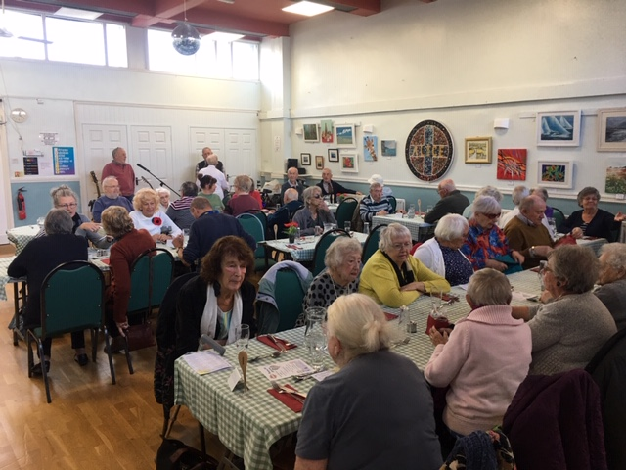

*Monthly Drive n Dine with Malcolm & Martin providing entertainment*

Waitrose (now closed), and Tesco surplus food is donated to us via the Fareshare scheme and Coop donate food also, helping to keep costs of ingredients down.

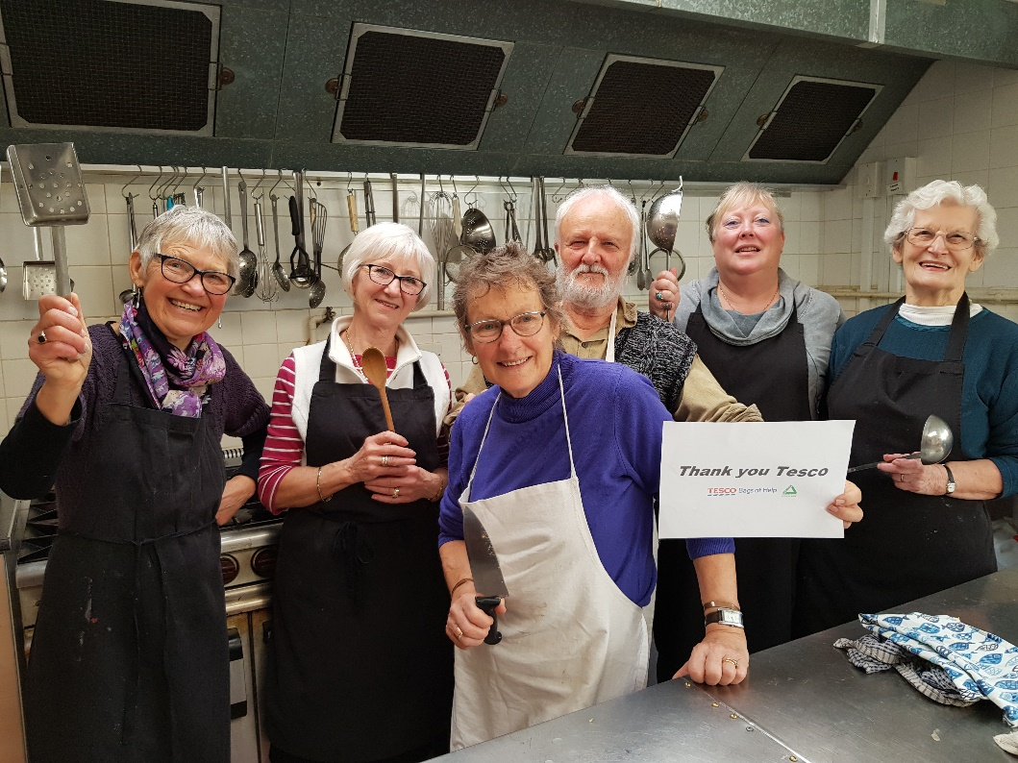

*Sunday Lunch kitchen volunteers*

Our tea and coffee bar is open 5 days a week and can provide a light snack for those who just want to come along and watch activities, or after their exercise or class. The bar is almost entirely run by volunteers and we are truly grateful for the time and effort they put in for us.

The Centre is available for hire in the evenings and at weekends for parties and celebrations and gatherings of all sorts and we can cater for these and provide a bar service if required. Private afternoon and evening functions where we provide catering and full bar service ensures the bar does not make a loss.

Our free Christmas Day lunch was again a great success, with approximately 80 diners and volunteers enjoying the festivities. The then mayor Cllr June Green ate with us and local councillor Phipps spent a couple of hours with us enjoying the festivities. Plans for this year’s Christmas lunch are now under way.

## Open Days & Special Events

We supported the new Sea Shanty Festival in September with our team of volunteers and were grateful to be recipients of a £500 donation.

We held several open days during the year –The Health & Wellbeing open day in May brought together local organisations and services to talk about and show our clients what is available locally. The NHS gave presentations on the multi-disciplinary team (MDT) and Pharmacy provision at Teignmouth hospital, VIH talked about the role of Health & Wellbeing Coordinators, Tozers provided information on wills and legacies, exercise taster sessions were available to try and the nurses gave health checks for those who wanted them. The Post Hope Group raised funds for Motor Neurone Disease and The Royal Voluntary Service gave a talk on alcohol awareness under their drink wise age well campaign and we shared “Mocktails” - delicious drinks made with no alcohol. A healthy lunch made by our team of volunteers was served. Trim Teign launched the next series of weight loss sessions and South West Coastal Path launched couch to coast.

100years centenary since the end of 1st World War was marked by a Remembrance Sunday attended by 70 people. Beryl Coombs, a lead volunteer, organised a magnificent show dedicated to the centenary raising funds for SSAFA & Alice Cross.

We were asked by the Town Council to be part of Armed Forces Day on the Den and to provide the catering there and our army of volunteers busied themselves baking cakes, making sandwiches and cream teas and happily serving the public all day with food and beverages. Our thanks to all who came along to taste our wares.

## Income/Fundraising

Income from activities and services increased to 46% this year (2017-18 45%) while grants remained the same at 6%. Income from private donors, local businesses and organisations and income from charitable trusts and foundations were evenly balanced. Many of the Trusts and Foundations which contributed to our activities last year have continued to support us this year and their invaluable support is very much appreciated. A gift aid return will be submitted in the next quarter.

We have held many fundraising events including music evening with The Glorious Rascals and singalongs with Amanda Lynn and The Teigns. Christmas Fayre, Christmas Day Lunch and Doreen Large and team helped to raise our profile locally by participating in numerous tabletop sales in both Dawlish & Teignmouth including the Carnival and Back Beach festival.

Teignmouth Art Society and our own art club regularly exhibit pictures in our hall and a share of proceeds of the sale of the pictures comes to the Alice Cross.

Total giving fundraising sponsored events by Brite Services - Glow in the Park & Devon Football Association - Spartan Race 2019 and our own Christmas Day page have helped raise £1,200.

Hugh & Liz Diamond have resumed some folk club evenings at the Alice as well as a Monday Open Mic night. We were delighted to have Teignmouth Poetry Society hold some events at the centre.

The Rotary Club of Teignmouth have held several very successful quiz and food nights raising funds for both Alice Cross & other organisations including Teign Heritage centre.

Income increased to £107,961 (FY 2017-18 to £94,122) and by carefully monitoring costs and outgoings we were able to reduce expenditure to £86,011 (FY 2017-18 £87,657) without impacting adversely on services.

## 

## Other Services

The centre continues to hold a regular foot clinic and delivers counselling and holistic therapies, including Swedish massage and pedicures, through partner organisations.The Royal Voluntary Service through Drink Wise age well provide alcohol support counselling and group sessions supporting the over 50’s with alcohol use. We continue to support the Teignmouth Community School Enrichment programme by providing cooking & craft sessions and many students take placements with us to gain work experience.

We host partner organisations such as Devon carers to provide support for carers locally and Teign Aid who support people facing homelessness and needing support in benefit applications.

Thank you to our trustees for supporting my role and to all the charity’s wonderful volunteers and friends for their continued belief in the aims and aspirations of this organisation. Your help will enable us to move with these changing times to create a centre of excellence in supporting the over 50s in Teignbridge.

## What our clients & volunteers say

## Centre User now Volunteer

Terry is a retired Psychiatric Nurse who has also specialised in IT and computers throughout his working life. He lost his wife 7 years ago. He first heard about the Alice Cross when he attended a talk given by the Centre Manager over 2 years ago. Terry now attends the Alice Cross most weekdays and always stays for lunch. He really enjoys the company and the opportunity to get out and do something which is stimulating and which he really enjoys.

“Having worked with computers for 21 years I feel privileged that the Centre Manager has entrusted me with computer-based work, and I find it both stimulating and satisfying.”

Jan says “The Alice Cross Centre was there for me. In March 2017 I lost my husband after 49 years of marriage. At the same time, I lost family – 3 Grandsons and friends of 40+ years. I would go out for lunch at local pubs and would be welcomed by staff but sitting by myself I was the loneliest person there. Everyone had someone.

I rang “The Alice” and Sheila – a volunteer – told me all about what goes on there. I went along and have never looked back. I now have a very large “family” and a warm welcome whatever time of day it is and whatever activities are taking place there.”

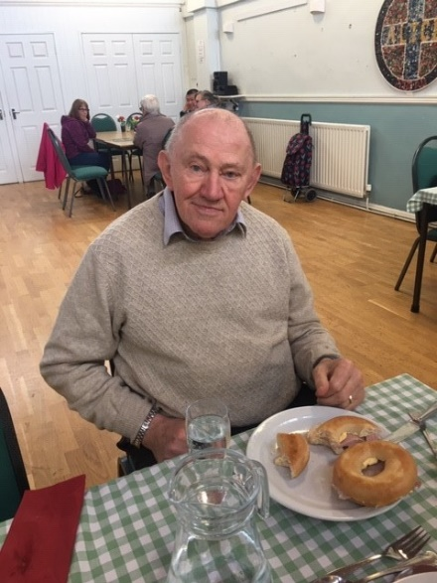

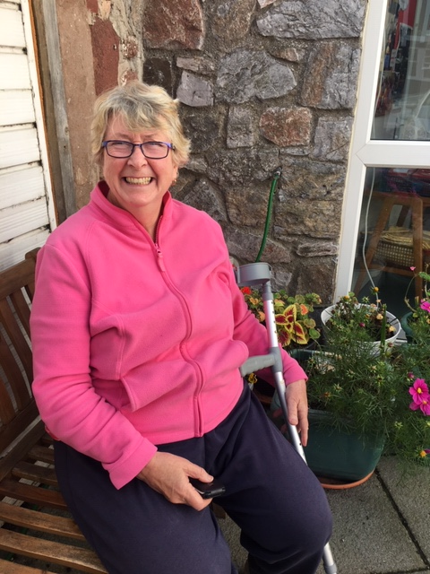

*Terry- centre user/volunteer*

Jan is a Centre user and helps make the front of the building look nice by tending the flowerpots along with supporting many of our activities.

*Jan- centre user*

**Volunteer**

“It was November 2017 when I walked into the Alice Cross Centre to offer my services as a volunteer. Looking back at that day, I did not know very much about the Alice Cross or the work of Age Concern charity and how much it would change my life for the better. I was quickly welcomed in to be part of an enthusiastic team of volunteers.

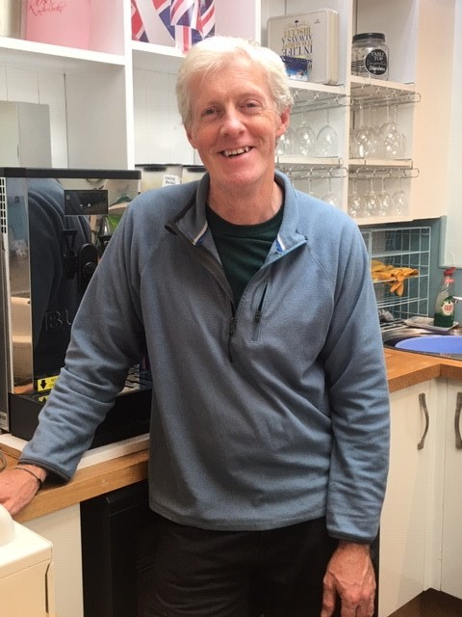Assisting with my first Christmas at the centre was really rewarding as many Christmases before 2017 had not been good for me.

The immediate response I had from becoming a volunteer was that I was no longer so lonely, making friends with other volunteers, the many visitors to the centre and also the people connected to Alice Cross from other organisations such as VIH. My social life has improved, and I now have people to socialise with in and outside of the centre.

Whilst volunteering I have been involved in many aspects of the centre from simple handyman (DIY) jobs, repairing things, moving furniture for events and general duties. I also use my van to help take items to tabletop sales in the summer. Early in 2019 I bought an MPV vehicle adapted to carry a wheelchair user. This has proved to be a valuable asset for the centre as visitors in wheelchairs can now be collected and driven to attend different events including Drive n Dine.

All in all, I have really enjoyed being a volunteer at the Alice Cross Centre and part of a team of dedicated and friendly people and it has made my life more fulfilling.”

*Ed - Volunteer*

**The Future**

We are involved with the work in the re configuration of NHS & Primary care services locally through attendance of regular meetings, whilst The Alice Cross will not relocate to the new GP site, we will be working very closely to provide additional services to support the NHS initiatives of preventative healthcare.

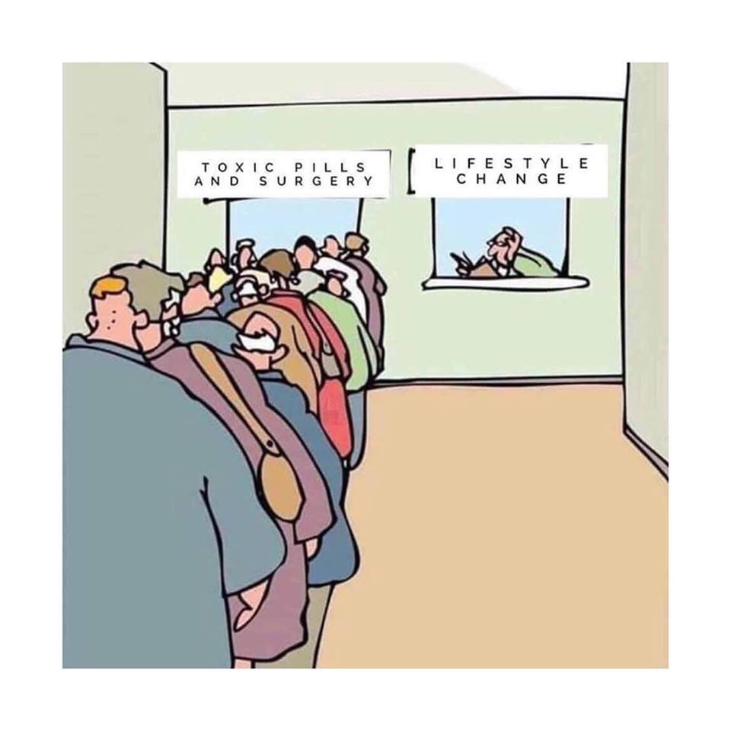

Nationally there is a focus on looking at lifestyle choices to improve people’s health and find alternatives to traditional medicine prescription. The aim is to change lifestyle so that longer term benefits can be achieved, and people take more responsibility for their health. This initiative is part of “Social prescribing” and will enable GP’s & healthcare professionals to offer other solutions such as referring to The Alice Cross to classes and activities, gym membership and volunteering as alternatives to prescriptions. A GP newly employed link worker, helping to bridge the gap between GP’s and local services and organisations that can support people in non-medical ways has been appointed.

We will continue to work in close cooperation with ViH, Assist, Teignbridge CVS and other local charities to reduce duplication of services and improve the support for all older people locally.

## Thank you

Finally, we would like to say a massive thank you to all our donors, volunteers, staff and partners, including any we have unwittingly not listed, for all the hard work and support you have given us over this last year.

AGE UK Devon Amanda Lynn

Albert Hunt Trust Alice Cross Eastern Dancers

Annandale Charitable Trust ASAP Printing

Assist Teignbridge B-C H 1971 Charitable Trust

Carers’ Pathways Clare Milne Trust

Cllr Sylvia Russell - Devon County Council Co-op Community Fund

Charity of Stella Symons Charles Hayward Foundation

Dawlish Community Transport Coop Teignmouth

Douglas Arter Foundation Devon Football Association

Dr & Mrs A Darlington Charitable Trust Elmgrant Trust

Fairfield Charitable Trust Fare Share

Green Hall Foundation Greenwood Accountancy Ltd

Heydown Trust H.I.T.S

Hugh Diamond- Teignmouth Folk Concert Incredible Fund

Jo Collet, Beryl Coombs, Anthony Powell, The Teigns John Vaughan

The League of Friends of Teignmouth Hospital Brite Services Ltd – Glow in the dark

Mayor & Cllr June Green

Marianne & Alan Gibson – musical quiz, Dancercise, PAT testing

Cllr Robert Phipps & the Promenade kiosks Norman Family Charitable Trust

Our fundraising committee members, Maggie, Sandy, Pat, Margaret, Doreen, Chris

Our evening volunteer bar team, Dave, Kevin, Louie, Lynn, Vanda

Our sing along entertainers Beryl Coombs, Jo Collett, Richard Wadey, Malcolm & Martin

Pete Williams- Pellow Carpet and flooring

Robert Phipps Jnr and the Adventure Golf kiosk

Rotary club of Teignmouth and Dawlish R S Brownless Charitable Trust

Sir John & Lady Amory’s Charitable Trust Sainsbury’s Dawlish

Sir Jules Thorn Charitable Trust (Ann Rylands programme) Scott Richards Solicitors

South Devon and Torbay CCG

Sportsbug – TDC Sport England

TAAG Teign Heritage Centre

Teignbridge CVS Teignmouth Town Council

Teignmouth Traders Association Teignmouth Shanty Festival

The 29th May 1961 Charity Teignmouth Dementia Action Alliance

Tesco Newton Abbot &Teignmouth Tesco Bags of Help Fund

Tozers Solicitors The Teigns singing group

Tracy Higgs Town clerk and team Tula Trust Limited

Volunteering in Health Viv Wilson MBE

Waitrose Teignmouth

Weatherheads Web Whistle Stop Cafe bikers

W G Edwards Charitable Foundation W O Street Charitable Foundation

Sincere thanks to a number of trusts, foundations and private individuals who prefer to remain anonymous for their support.

If you would like to sponsor an activity or event at Alice Cross, please do get in touch!

**Julia**

Julia Street – Operations manager