Mental Capacity Act 2005
A practical guide for Alice Cross Centre staff and volunteers
The Mental Capacity Act applies in England and Wales to people aged 16 and over. It helps us respect a person’s choices and support them when they may have difficulty making a particular decision. In our centre, start by speaking directly to the person and helping them decide for themselves.
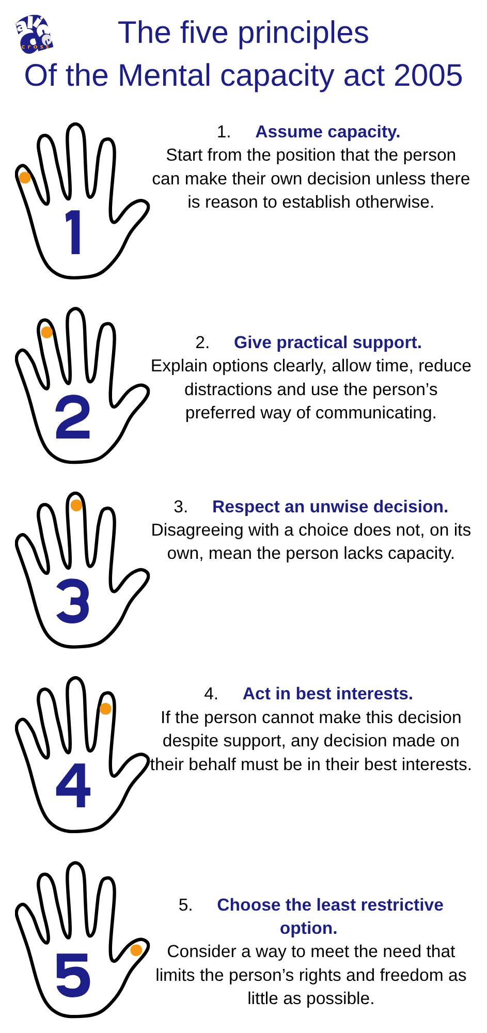
The five principles:
Assume capacity. Start from the position that the person can make their own decision unless there is reason to establish otherwise.
Give practical support. Explain options clearly, allow time, reduce distractions and use the person’s preferred way of communicating.
Respect an unwise decision. Disagreeing with a choice does not, on its own, mean the person lacks capacity.
Act in best interests. If the person cannot make this decision despite support, any decision made on their behalf must be in their best interests.
Choose the least restrictive option. Consider a way to meet the need that limits the person’s rights and freedom as little as possible.

Capacity is about one decision at one time
A diagnosis of dementia, a learning disability or confusion does not automatically mean someone lacks capacity. Capacity can change with the decision, the time of day, illness, distress or the support available. A person may choose their lunch independently even if they need help with a complex financial decision.
The legal test asks whether an impairment or disturbance of the mind or brain means the person cannot make the specific decision when it is needed. The person must be able to understand the relevant information, retain it long enough, use or weigh it, and communicate a choice by any means. Staff and volunteers should not label someone as generally “without capacity”.

What to do in everyday practice
Ask the person what they want. Offer simple choices, clear words, pictures or other communication support. Give them enough time; try again later if appropriate.
Notice and respect a clear refusal. Do not pressure, trick or physically force a person to accept food, take part in an activity, share information or leave with someone.
If a choice raises immediate safety concerns, stay with the person if safe to do so, seek the duty manager or General Manager promptly, and call 999 if someone is in immediate danger.
If you are unsure whether someone can make a particular decision, tell the duty manager or General Manager. Describe what happened and what support you tried. Follow safeguarding and incident reporting procedures; record facts, not assumptions.

If a person cannot make a particular decision
The appropriate decision maker must consider the person’s wishes, feelings, values and past preferences; involve them as far as possible; consult relevant people where appropriate; and consider whether the decision can wait until the person may regain capacity. Family members or carers do not automatically have legal authority to decide for the person. An attorney or deputy may have authority for certain decisions, but staff should refer questions about that authority to the General Manager.
Volunteers should refer decisions beyond routine support to the duty manager or General Manager. Staff should follow the centre’s policies and seek appropriate professional advice for complex, disputed, medical, financial or restrictive decisions. Keep a proportionate record of the decision, the support offered, concerns raised and who was consulted.

Example at the centre
A Memory Café attendee declines a group activity. Explain it in a way they understand, offer another activity or a quieter space, and respect their choice. If they appear suddenly confused or unwell, alert the duty manager. Do not assume that attending Memory Café removes their right to choose.

Further reading
Alzheimer’s Society, Dementia and the Mental Capacity Act 2005: https://www.alzheimers.org.uk/get-support/legal-financial/dementia-mental-capacity-act
Mental Capacity Act Code of Practice: https://www.gov.uk/government/publications/mental-capacity-act-code-of-practice
NHS, Mental Capacity Act: https://www.nhs.uk/social-care-and-support/making-decisions-for-someone-else/mental-capacity-act/

